Ventricular Repolarization and T-wave Alternans Preceding the Onset of Spontaneous Sustained Ventricular Tachycardia
Kelley P. Anderson MD, Anna Beigel BS, Vladimir Shusterman MD, PhD Cardiovascular Institute / UPHS, Pittsburgh, PA

Increased T-wave alternans (TWA) has been reported to precede the initiation of ventricular tachyarrhythmias (VTA) in experimental studies. We hypothesized that increased TWA and dispersion of ventricular repolarization precedes and, possibly, facilitates the initiation of spontaneous VTA. To test this hypothesis, indices of repolarization in 53 Holter ECGs with spontaneous sustained monomorphic ventricular tachycardia (VT_{sm}) were examined.
Methods: Beat-to-beat changes in the indices of repolarization including QT, activation-recovery interval (ARi), QRST-integral, T-wave amplitude (TA), QRST integral (QRSTI), and T-wave alternans (TWA) were averaged in 5min windows and the trends were examined using nonparametric Friedman ANOVA.
Results: RR and QT-intervals shortened during 60 min before the onset of VT_{sm} (RR:613 + 143 to 580 + 113 ms, p=.018; QT:395 + 53 to 385 + 47 ms, p=.028). Mean ARi was shorter during 15min before the onset than the 24-hour average (236 + 45 and 228 + 48, p=.003). TA and QRSTI did not change significantly (TA:.037 + .052 and .034 + .051 mV, p=.50, QRSTI:4.14 + 6.16 and 3.68 + 6.03 normalized units [nu], p=.58). TWA increased during 45 min before the onset (.021 + .017 and .25 + .020nu, p=.060).
Conclusions: An increase in T-wave alternans and dissociation between shortening QT-interval and unchanging QRST-integral and T-wave amplitude precede the onset of VTA. This supports the theory that dynamic repolarization abnormalities participate in arrhythmogenesis.

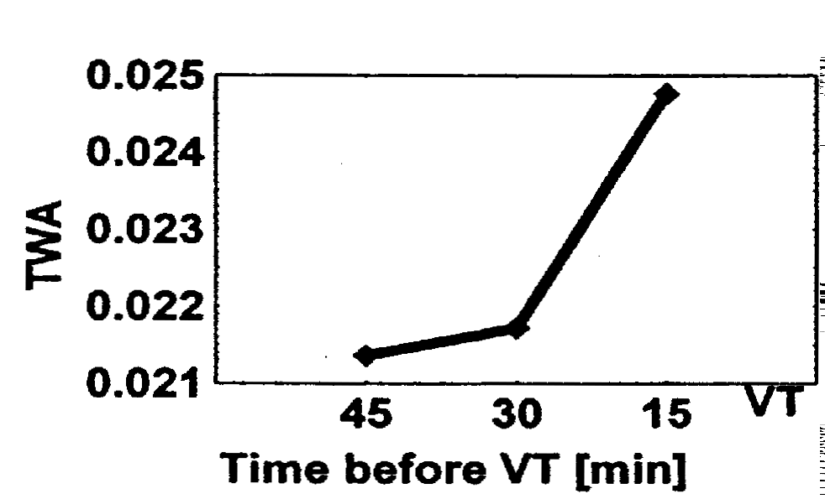
Figure 1. Changes in T-wave alternans preceding the onset of VTA.

